# Topic 1: C First Acquaintance

### Guidance

1. Why do we use C in embedded system**?** Why don't we use other high-levelProgramming Language, like Java/Python/C++? Why don't use assembly language?
2. What is a compiled language? What is an interpreted language? Which languages are compiled? Which languages are interpreted? What's the difference between them? What are the advantages and disadvantages?
3. What is syntax checking in compilation and What is semantic checking? What's the difference between them?
4. What are the steps and tools needed to go from a C program to an executable program? What do these tools do? Why are these steps needed?

### Practice

1. Use different options in gcc to see the input, output and role of different compilation tools

|  |  |  |  |  |
| --- | --- | --- | --- | --- |
| tool name | pre-processor | Compiler | Assembler | Linker |
| gcc tool | gcc built-in | cc1 | as | collect2 |
| gcc option | -E | -S | -c | -o |
| function | Expand header file, macro definition, conditional compilation and so on | Change C code to assemble code. It includes lexical analysis, grammatical analysis and semantic analysis | Change assemble code to object file. Which is binary machine instruction | Link different object files and library files to an executable file |
| input | source file | expand file | assemble file | object file |
| output | expand file | assemble file | object file | executable file |

1. Use readelf to view the composition of an executable file. What sections are made up of an executable file? Draw a picture. What do these sections do?

|  |  |
| --- | --- |
| The major composition of an executable file | |
| ELF Header | Records the basic properties of current file.  Contains pointers to the locations of Section Header Table and Program Header Table within the ELF file |
| Section Headers | Describes the information for each section. Be used by the linker |
| Program Headers | Be used by the loader  Only exist in executable File |
| Others | We don't have to pay attention right now |

|  |  |
| --- | --- |
| The type of ELF Header | |
| Relocatable File | Contains code and data that can be used to link to executable files or shared object files, and static libraries can also be classified as such |
| Executable File | Files that have been relocated |
| Shared Object File | Contains code and data.  in two cases:   * a static linker that can be used for relocation to produce new object files, * a dynamic link library such as.so and.lib. |
| Core Dump File | The dump file is generated after a program crash. It saves various crash scenes and can be used to analyze and debug the cause of the crash. |

|  |  |  |
| --- | --- | --- |
| Description of major sections | | |
| section | description | data |
| .rodata | read-only data | leave it out for now, follow up later |
| .bss | uninitialized global and static variables |
| .data | initialized global and static variables |
| .text | machine instructions, only 1 copy, read only |

1. Is it possible to mix C and assembly programming? How to do it? (You can find examples on the Internet to verify.)

Only need to know the usage of keyword asm

# Topic 2: Basic Concept

## Constant

### Guidance

1. What is constant?
2. Which type of constant do you know?
   1. number. different base
   2. character. storage, representation, special characters
   3. enumeration.
   4. string. storage, representation
3. keyword const. global and local variable

### Practice

1. How to representation characters? How to store characters? Write a program to describe the relationship between ASCII and characters

In C, characters are printed with %c and numbers are printed with %d. Here we can look at the difference between characters and numbers by printing in.

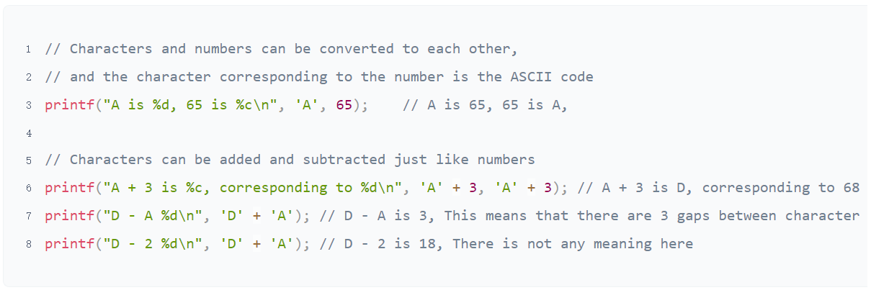

The are 128 characters in ASCII code

|  |  |  |
| --- | --- | --- |
| 0-31 | control | non displayable |
| 127 | control | non displayable |
| 48-57 | 0-9 | digit |
| 65-90 | A-Z | uppercase |
| 97-122 | a-z | lowercase |
| others | Do not need to remember | displayable |

1. What are the special characters? What do they do? How do I print special characters?

Broad definition：All characters except numeric uppercase and lowercase are special characters

Narrow definition：control character(0-31,127) + escape character(some of here is also control character)

1. How to define and represent different base in C? Write code to illustrate

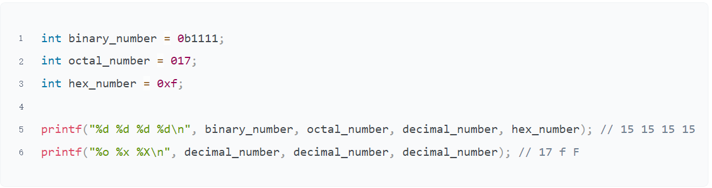

1. How to define and use enumeration? Write code to describe

* Enumeration can help coder better understand code and enhance the readability of code

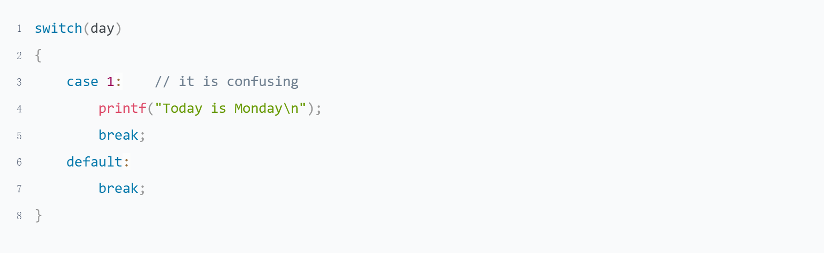

* The usage is very flexible

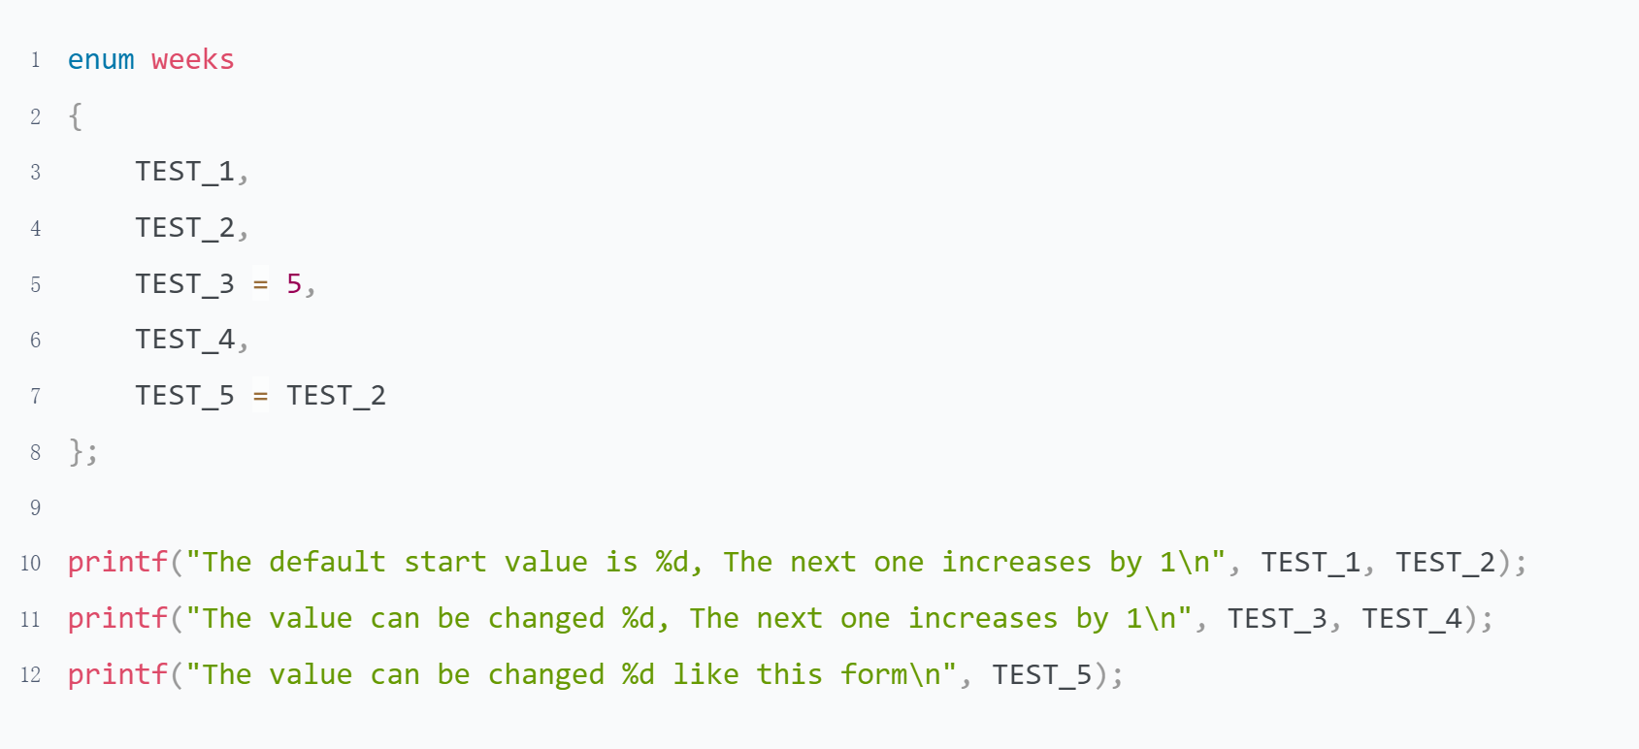

* It can also be combined with a typedef to define a type（leave it out for now,follow up later）

1. Why do we say string is constant？Illustration

* Compare the output of a and b with objdump -h to see which part is 7 bytes larger

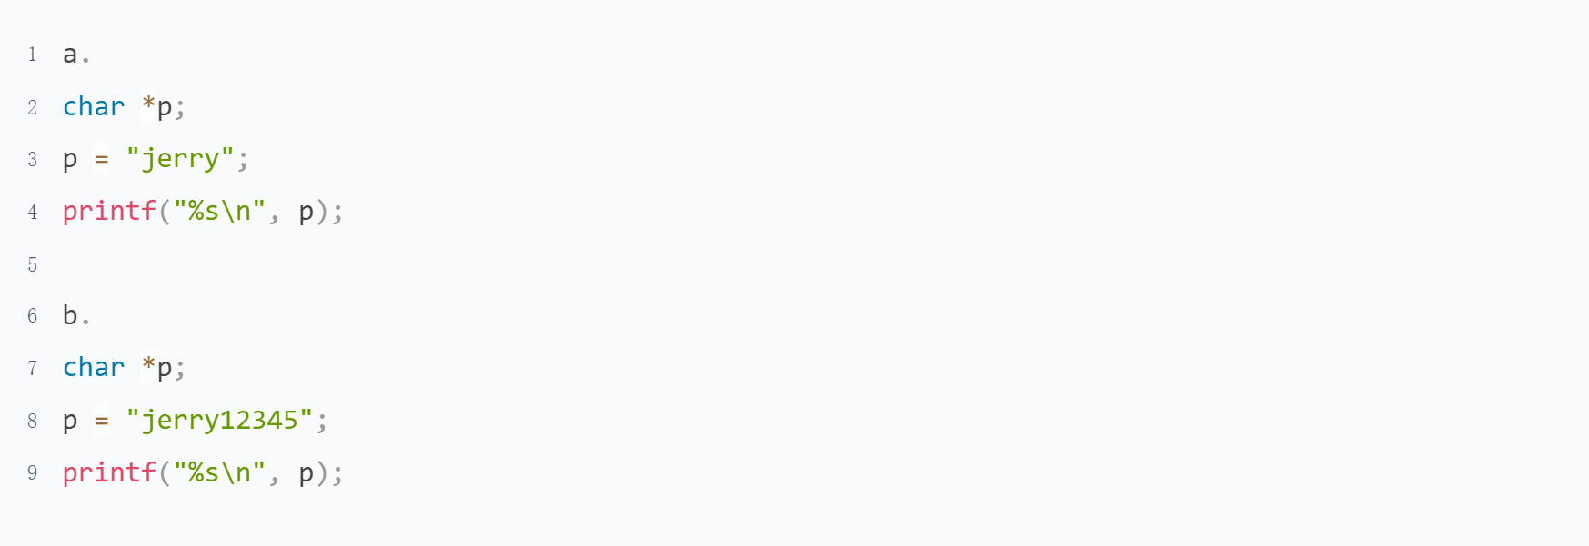

* To check the address.Leave it for you

1. Can we change the value of a const variable? How to do?

It's different for global and local variables.

global variables declare by const are stored in .rodata, they cannot be modified anyway.

The corresponding local variable is stored on the stack and can be modified by pointer.

## Variable

### Guidance

1. Composition of variable
2. Data Type
3. local and global variable

### Practice

The Linux tools objdump and readelf can help you know more about that how a variable be stored in memory

1. What are the rules for constitute the variables?

* The variable name consists of letters, digits and underscores, starting with a letter or an underscore. Normally a variable starting with a letter used for normal user, and starting with underscore used for system base functions.

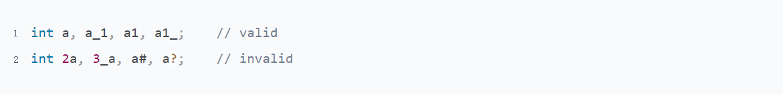

You can find here, There are really many functions which name is start with underscore

<https://github.com/torvalds/linux/blob/master/include/linux/socket.h>

* There are 32 reserved words in C programming language, the variable name defined cannot be the same with the reserved word.



* Variable names are case sensitive.



* Variable names should be as meaningful as possible Which can improve code readability

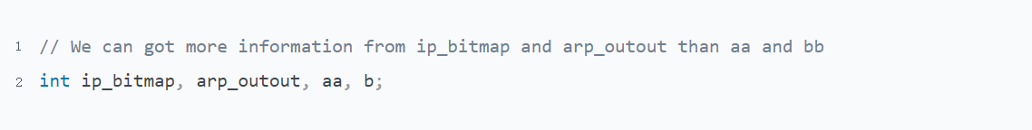

1. What are the types of variables? What's the difference between them?

Misunderstanding

1. How to define and use variables? Assign and Use

* The variable need be define before to use it
* We can give the value when define it, The format is = ;
* We also can define it without value assign.The format is ;
* We need set the variable on left side and value on right side when do the assignment. =
* The variable can be used after it be assigned a value

1. What is the nature of a variable name? Illustration

Variable Name is only exist when the program was a C code. Then it will become a address.

1. Where do computer store local and global variable in memory? Topic 1->Practice->question

Refer to program "The address of constant and variable.c"

1. Why do we need static to declare a variable?

* When it used as a global variable, the scope of the variable changes to the file which define it, that is mean, the variable cannot be used in a source file other than the current file.
* When it used as a local variable, the variable is stored in the global variable table. The lifetime of the variable does not depend on the call stack.

1. What is different between local and global variable when it declare by static? And Where the computer store them in memory? Topic 1->Practice->question

Refer to program "The address of constant and variable.c"

## Operators and Expressions

### Guidance

Pointers On C.pdf -> Chapter 5

### Practice

1. What are the rules of expression operation?

You can understand it in your own way and don't need to memorize it. In particular, the priority problem can be solved by parenthesis if you are unsure when programming.

This helps to improve the readability of the code, but it is necessary to know some priorities, otherwise adding too many brackets will affect the readability of the code.

This question is more subjective, you can judge for yourself, I give a few of my habits, as an example. It's not mandatory here.

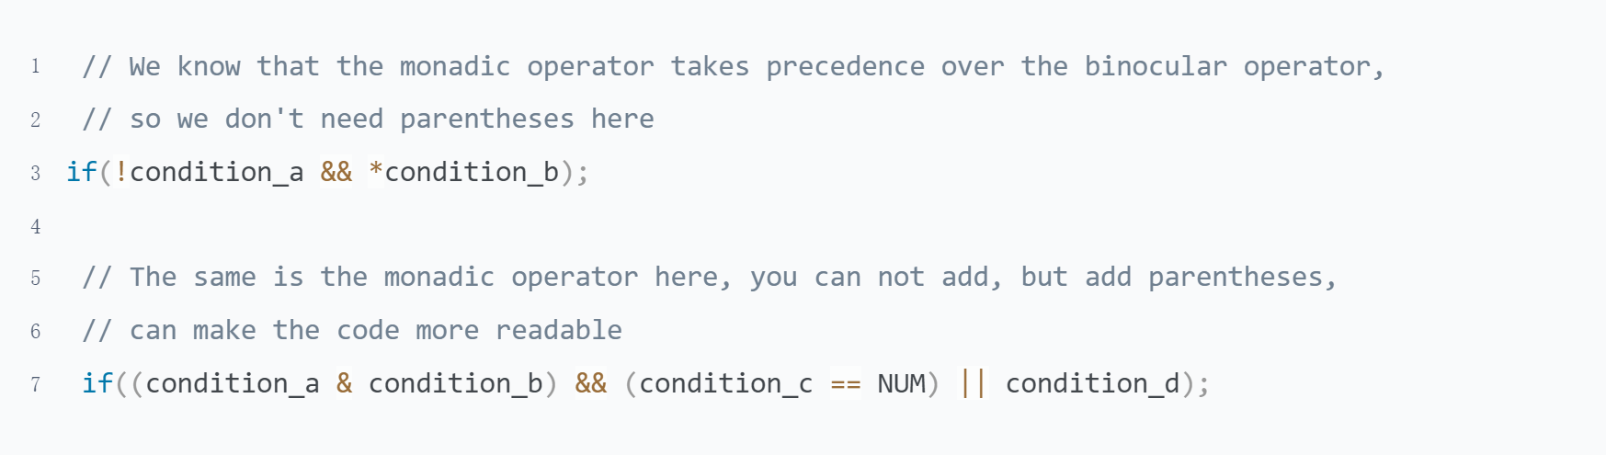

1. Pointers On C.pdf 5.8 question 5

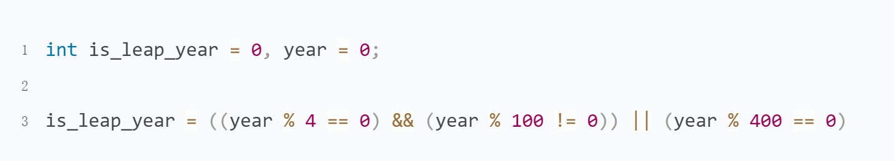

1. Pointers On C.pdf 5.8 question 6

side effect:There are some operators change the behavior of operands, and we call this change a side effect

The operators who have side effect:increment/decrement operator, assignment and compound assignment operator

Attention：Increment/Decrement operator is not recommended to use unless there is only one statement in the expression

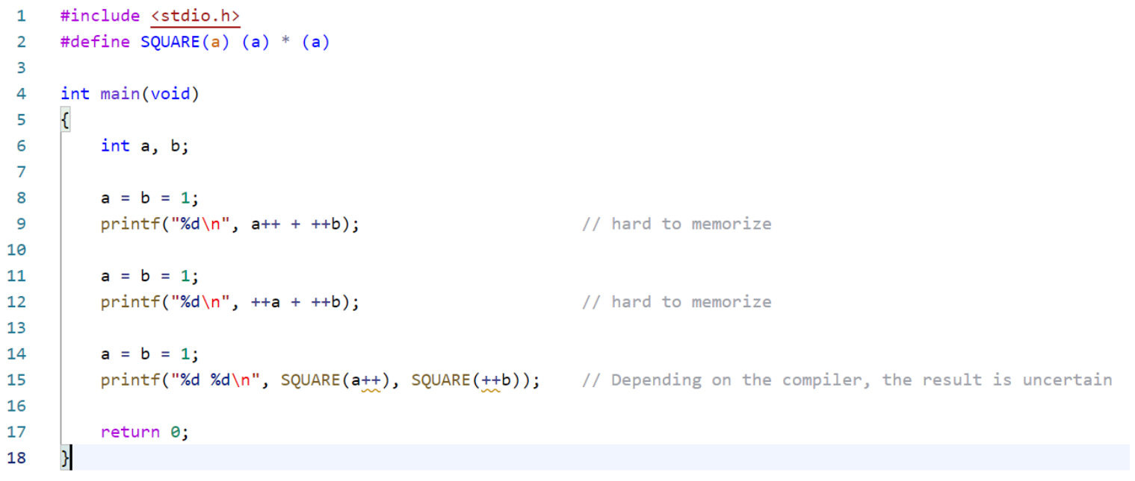

1. Pointers On C.pdf 5.8 question 7

Computers can't think as flexibly as people, and they need to follow the rules of operators.

Both operators have the same priority and are executed from left to right.

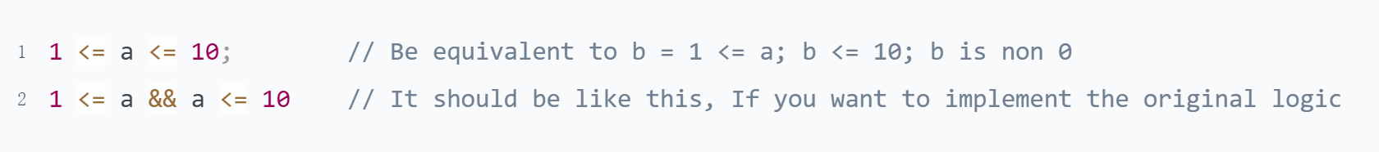

1. Pointers On C.pdf 5.8 question 12

There are 2 kinds of way used for right shift in C, arithmetic or logical shift. The rules as following

|  |  |  |
| --- | --- | --- |
| unsigned | logical shift | fill the left always end with 0 |
| singed | arithmetic shift | fill the left end with repetitions of the most significant bit |

More detail to reference Computer Systems A Programmer's Perspective.pdf -> 2.1.10

For current question, we can do determine to use program as following

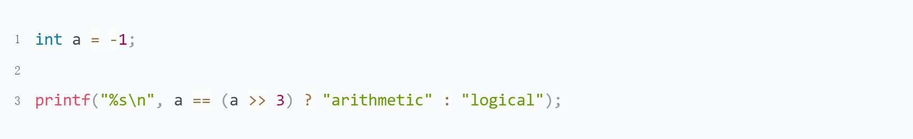

1. Pointers On C.pdf 5.9 question 3

There are 2 points need to note:

* To apply what you've learned, it's easier to use the shifts you've just learned.
* Integer type is not always 32 bits. The program should be portable

1. What is the output of the following program? Why?

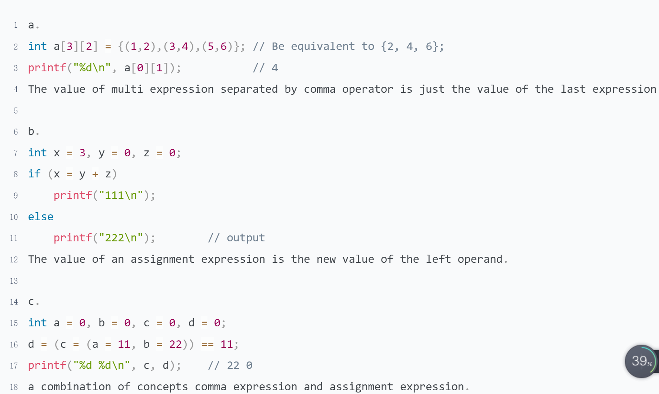

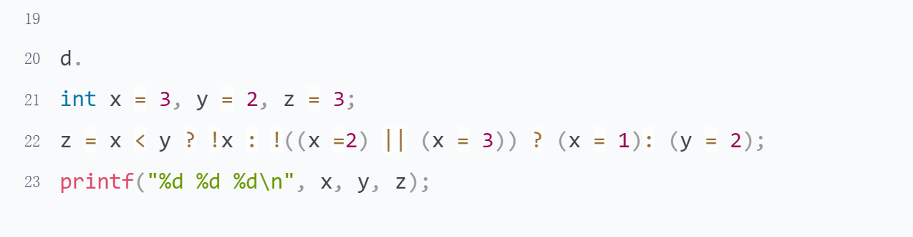

This answer for c and d get from Mormo

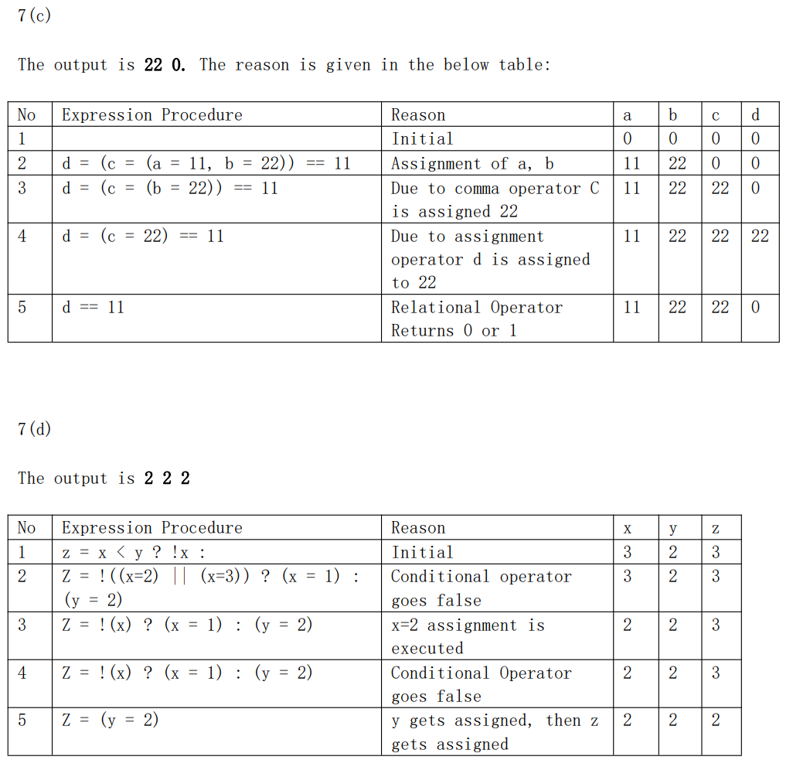

## Macro & Typedef

### Guidance

1. What is typedef? Is it used for create a new type?
2. Why do we need typedef?
3. Pointers On C.pdf 14.2
4. The name of micro & typedef(reference the Programming specification doc)

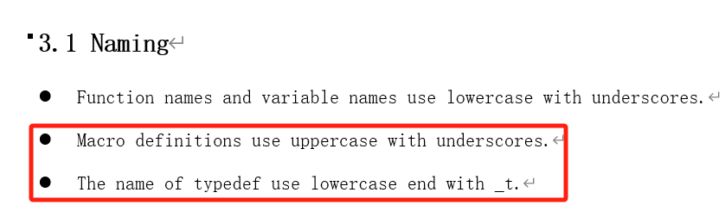

### Practice

1. What is the different between define and typedef? Illustration

|  |  |  |
| --- | --- | --- |
|  | define | typedef |
| nature | replace text | type alias |
| timing | pre-processing stage | compile stage |
| mode | replace text only | a part of compile, including type check |
| function | Used to define constants or long string replace | Simplify complex declarations |

Both define and typedef can help simplify code and improve its readability. But sometimes they are different

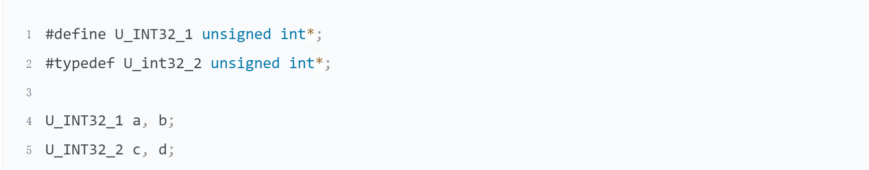

1. How to define a macro function? What are the points for attention?

* Do not forget to put every expression enclosed in parenthesis

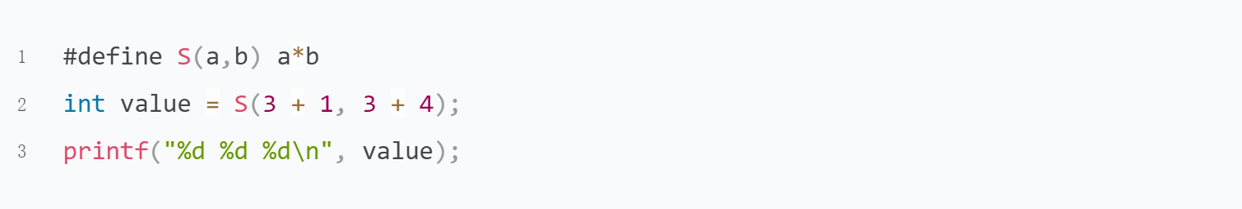

* Avoid to use the operator that may cause side effect

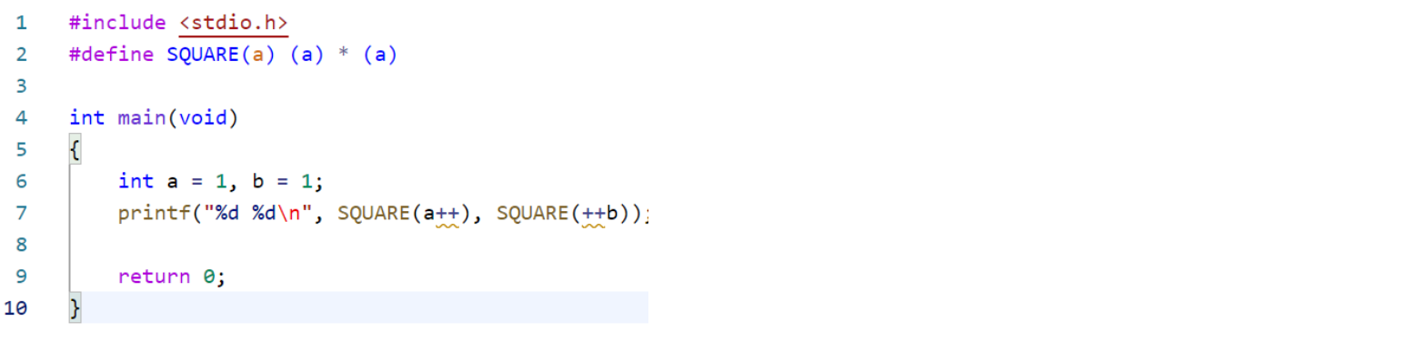

* Do not end with semicolon, it's not a statement

1. Pointers On C.pdf 14.9 question 2

* Improve program readability. We can know the meaning of the constant from macro name easily
* Increase program maintainability. All it takes is one change if we need to change the value of macro

1. What is the type of T1?

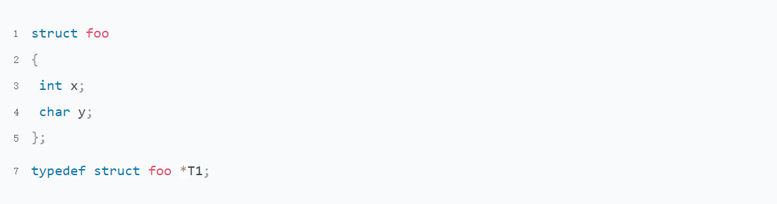

The type of T1 is struct foo *

1. Define a macro swap(t, x, y) that interchanges two arguments of type t.



1. Write a macro MIN that accepts three parameters and returns the smallest one

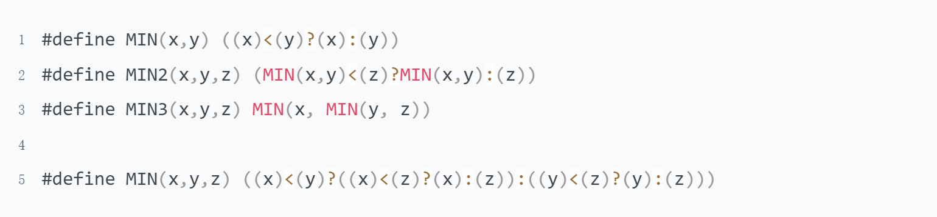

1. When do we need typedef? Illustration

I think it is better to use typedef here

* used for pointer

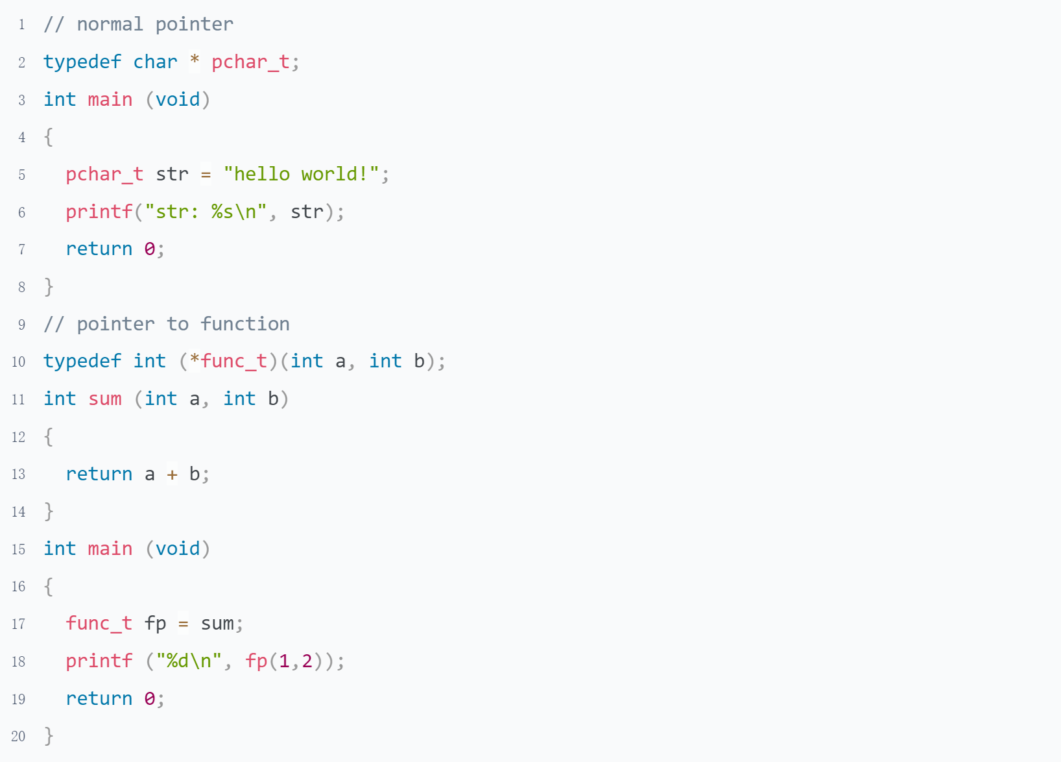

* Increased portability of code.

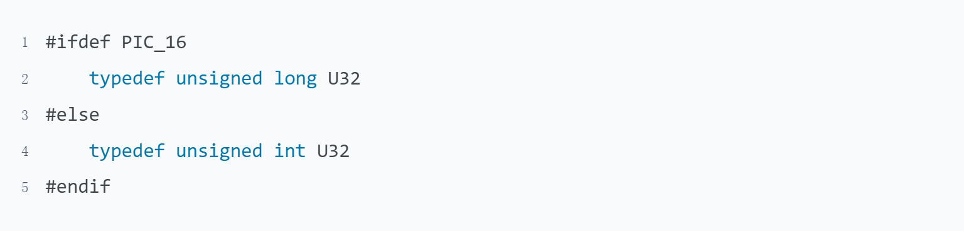

* Simplify complex definitions

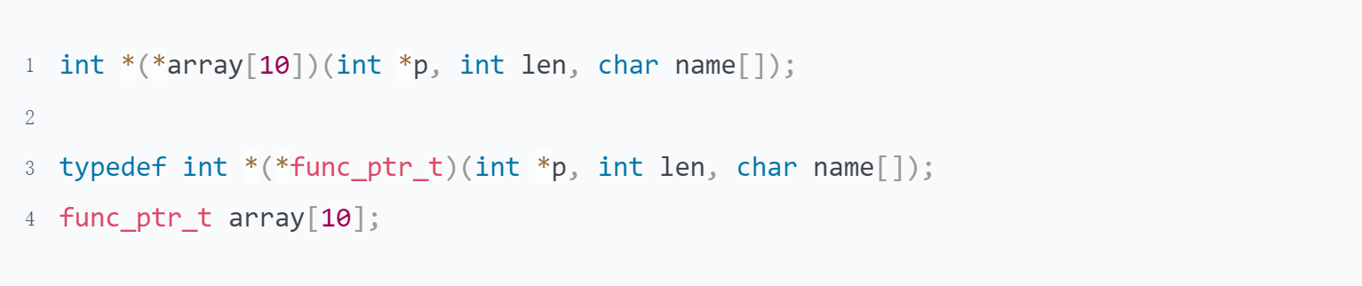

I do not think it is better to use typedef here

* Used for struct, It can save a keyword struct, but loses the information that it is a struct

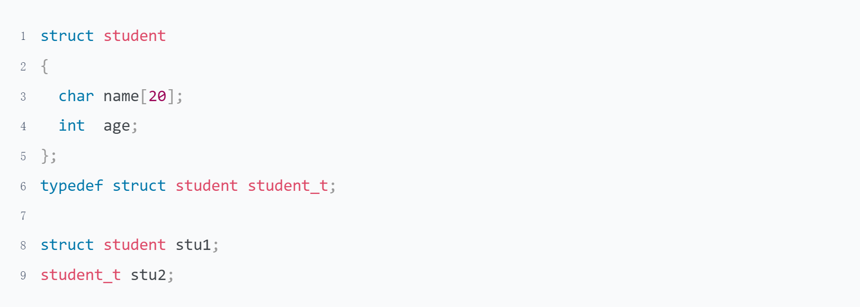

* Used for array, Do not conducive to code readability, need to look at the definition

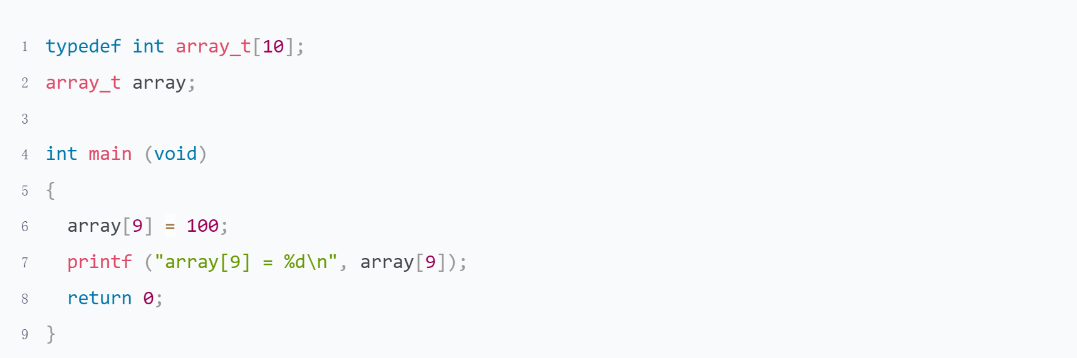

* Used for enumeration, It can save a keyword enum, but lose the information that it is a enumeration

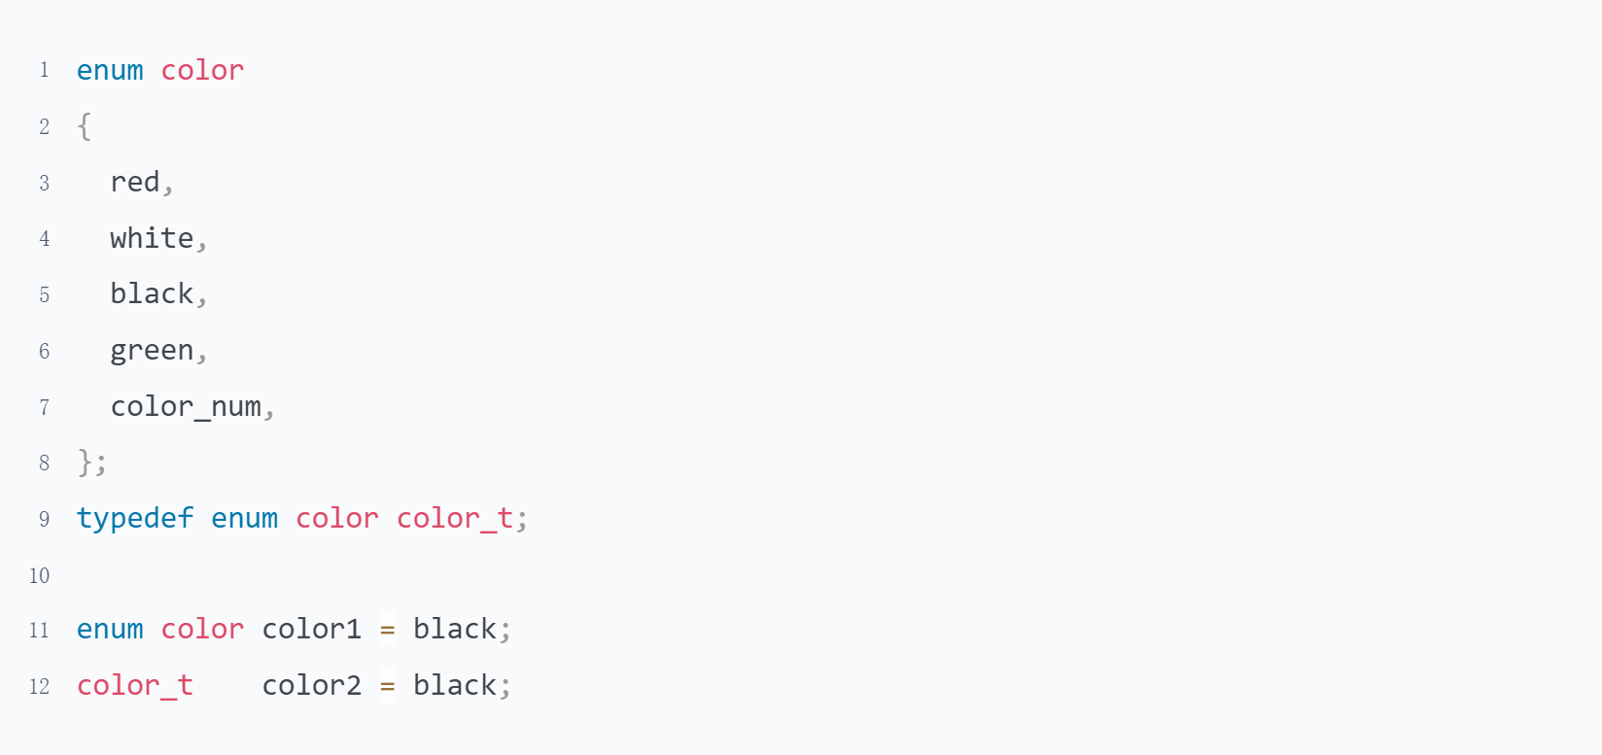

1. What is the different between macro function and normal function?

|  |  |  |
| --- | --- | --- |
|  | macro function | normal function |
| nature | replace text | function call stack |
| timing | pre-processing stage | running stage |
| advantage | Do not need new stack | Call function are not affected |
| disadvantage | Expanding makes the call function become larger, increasing the cost of calling the function | Need new stack and register |

# Topic 3:Control Flow

## Selection Statement

### Guidance

Pointers On C.pdf Chapter 4.1-4.4 4.8

The C Programming Language 2nd.pdf 3.1-3.4

1. What is the relationship between e**xpressions and statement?**
2. bool type
3. Why do we need to indent if the compile allow us write code like this?

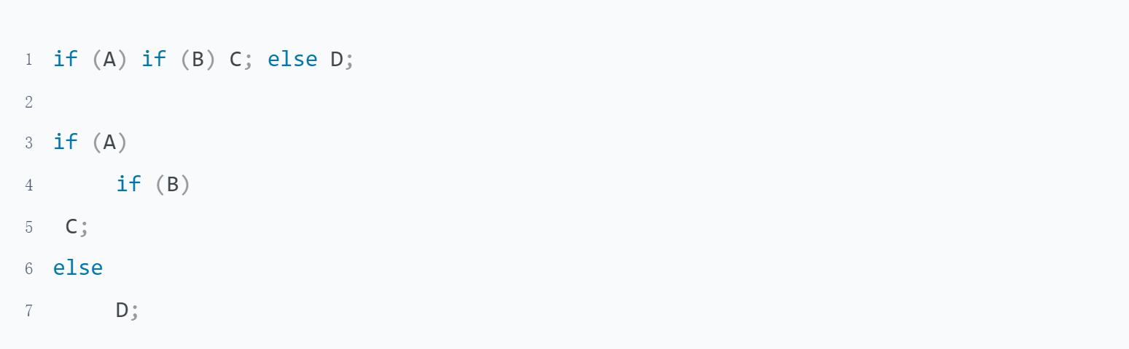

### Practice

1. What is the function of control statements? What kind of form it can be?

Control statement is a statement used to control the selection, loop, turn, and return of a program flow.

Control expression can be any form

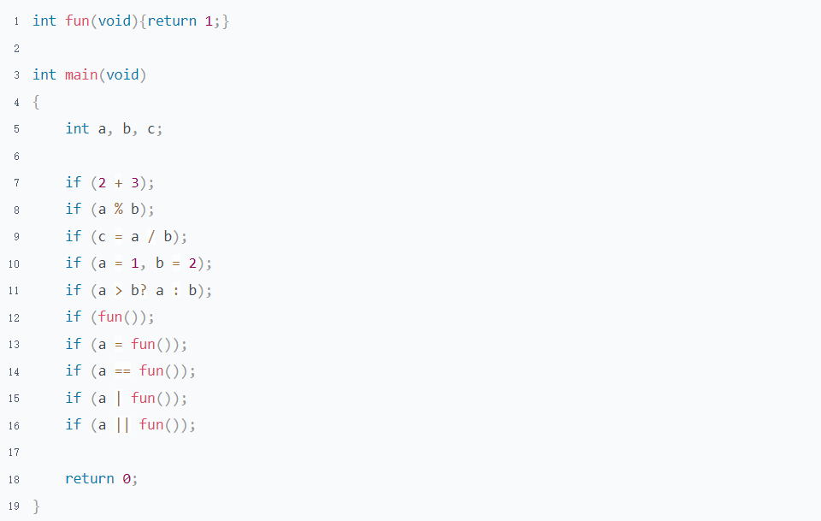

All uses of if can also be used to while/for/switch/return

1. How many control statements can C code have? How many categories can we divide them into?

There are 9 control statements be devided into 3 categories

|  |  |
| --- | --- |
| category | control statements |
| Selection | if, switch |
| Loop | while, do while, for |
| Turn to | break, continue, return, goto |

1. How many kinds of selection statements are there? What are their application scenarios?

* It is simpler to use if when the value of an expression is range, and to use switch when the value of an expression is definite

example:A class will be graded according to the requirements of 0-59: E-level 60-69: D-level 70-79: C-level 80-89: B-level 90-100: A-level

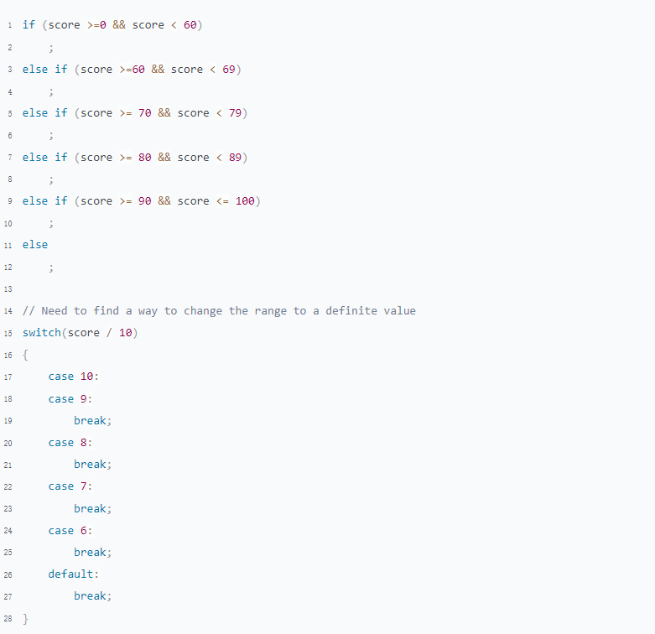

* It is convenience to use if in multiple condition
* The control expression of if use logical expression and switch use arithmetic expression.Because the result of a logical expression is 0 or non-0

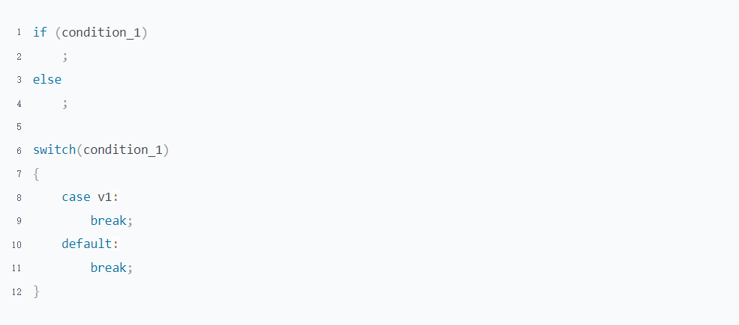

* Some compilers optimize the switch statement to make instruction execution more efficient.(Need more research)

1. How many forms of an if statement?

There are 3 forms of if statements

|  |  |  |  |
| --- | --- | --- | --- |
|  | if | if-else | if-elseif-else |
| description | only need logical true | logical true or false | Multiple logic or need arithmetic results |
| syntax | if (control expression)  ; | if (control expression)  ;  else  ; | if (control expression 1)  ;  else if (control expression 2)  ;  else if (control expression ...)  ;  else  ; |

1. What should we pay attention to in the switch statement?

* The value of case must be a inter
* The case lable must be unique
* Do not forget to add after case statement otherwise a fall-though will happen
* Do not forget to add default statement end with all of the case,which can help you catch the case that you thoughtless
* The Statements that do not put in a case statement will not be executed

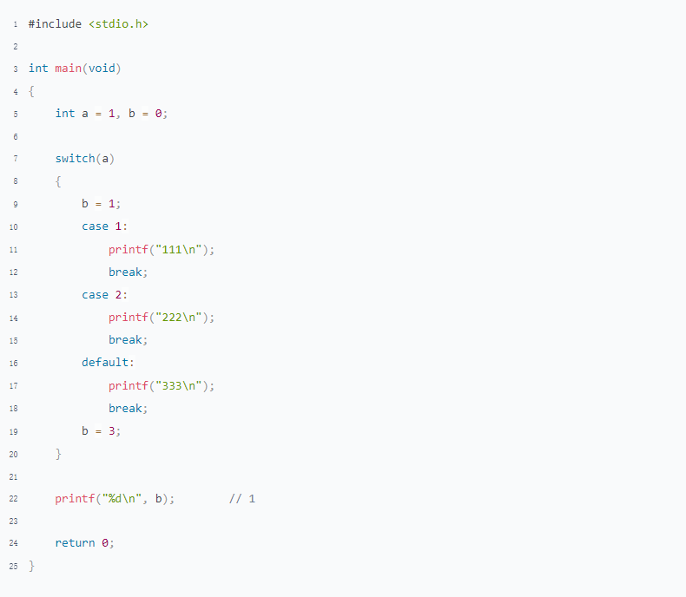

1. What is Dangling-else? Illustration

The rule of an else match with if is that it will match with the if closest with it.

Therefore, Something will happen that out of our expect if we wrote if without brace

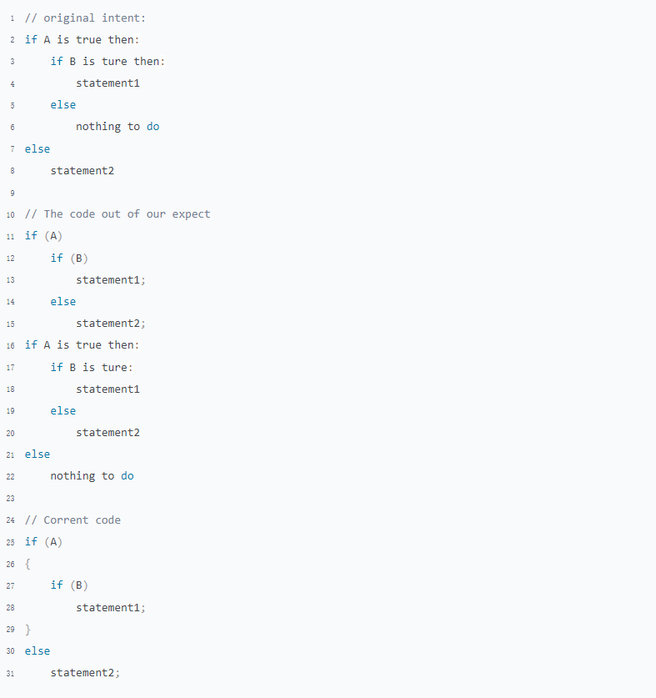

1. What is switch fall-though？What are its advantages and disadvantages?

Advantages:Avoid writing duplicate code.Make the code look cleaner

Disadvantages:Multiple cases reuse the same code. If the logic of one branch need to change, it's easy to forget about fall-though, so that the logic of the other cases is also modified

1. Pointers On C.pdf 4.13 question 4

There are 2 approaches can be taken in this case

* empty statements
* get logical not of the control expression

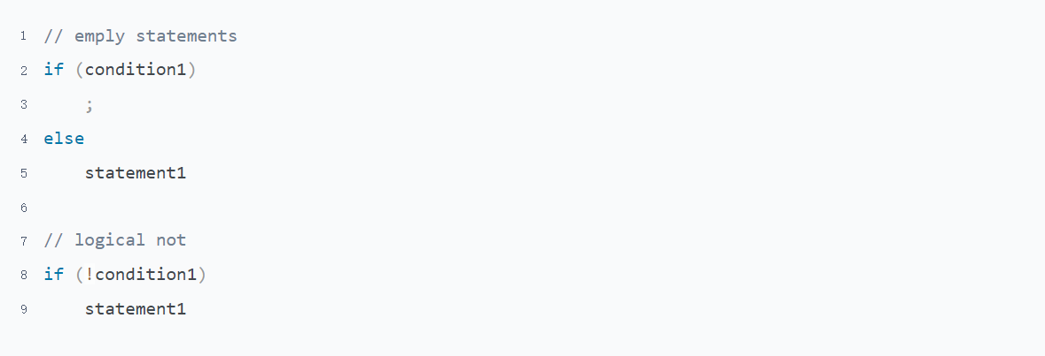

1. Pointers On C.pdf 4.13 question 16

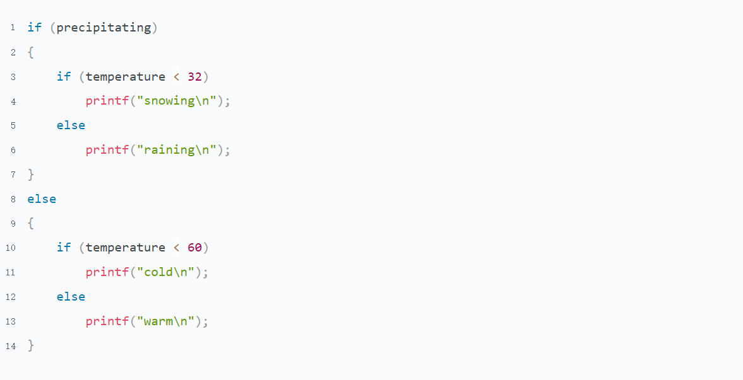

## Loop & Goto Statement

### Guidance

Pointers On C.pdf Chapter 4.5-4.7 4.9

The C Programming Language 2nd.pdf 3.5-3.8

1. What is the execute order of the 3 parts of the for control expression?
2. How to convert between while and for?

### Practice

1. How many kinds of loop statements are there? What are their application scenarios?
2. What is the different between following 2 programs? Give me an example to illustrate the impact of these two methods on the actual results

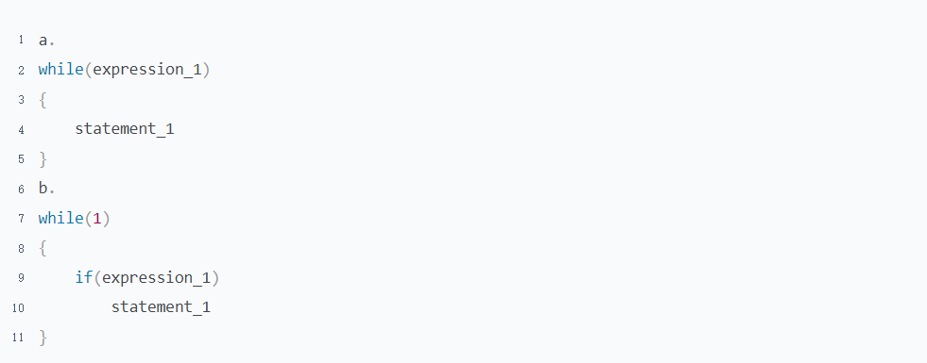

1. What are the difference between break, continue and return when we use them in a nested loop? Illustration
2. What are the difference between break and return when we use them in a case statement?
3. Pointers On C.pdf 5.8 question 8
4. What are advantages and disadvantages of goto statement?

# Topic 4:Function

## Basic Knowledge

### Guidance

Pointers On C.pdf 3.5

Pointers On C.pdf 7.1-7.3 7.7-7.9

1. Can variables defined in one function be accessed in another function?
2. What will happen if you define a function with the static keyword?
3. Write a simple program and read the according assembly language
4. Function define/declaration
5. Inline function